# ChangeLog

|  |  |  |
| --- | --- | --- |
| **Date** |  | **Changes** |
| 16-04-18 |  | First copy of the functional design [empty] |
| 17-04-18 |  | Filling in every subject |
|  |  |  |
|  |  |  |
|  |  |  |
|  |  |  |
|  |  |  |
|  |  |  |
|  |  |  |

# Story and background

You are pretty good with riding a bike and you want to show of your skills, lucky for you there’s a competition in town where the big price is a brand new customized bike. Since that bike will defiantly be better than the one you got right now you decide to enter the competition to win the grand prize.

|  |  |  |  |  |
| --- | --- | --- | --- | --- |
| **Characters** |  | **Description** |  | **Purpose** |
| [other/customized] Players |  | You and everyone you’re up against |  | It’s an online game so you want to race against other players |
| [other/customized]  Bikes |  | You can customize your own bike for each obstacle you might come across |  | This will be the bike you’ll win if you win the competition, if you have more of a sport bike you’ll have a little advantage in rougher terrain |

# Screen flow

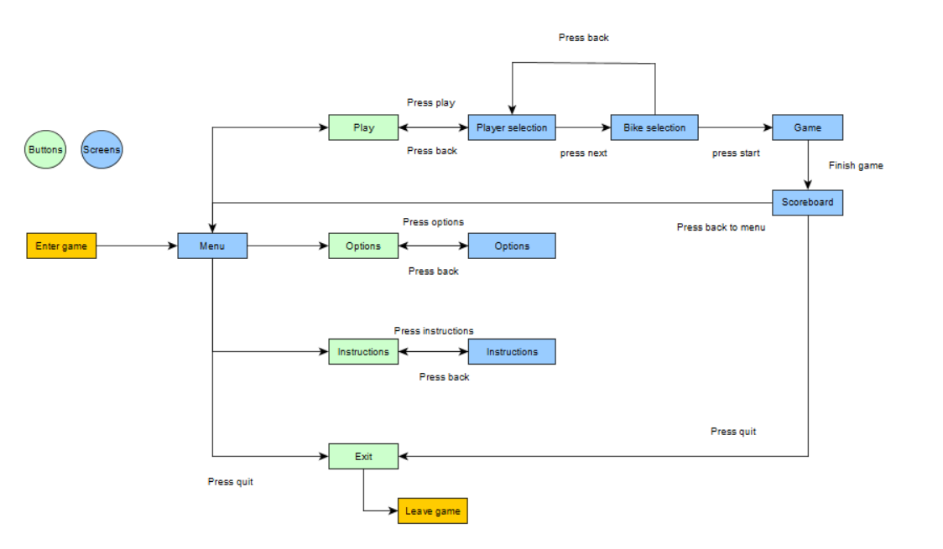

# Wireframes

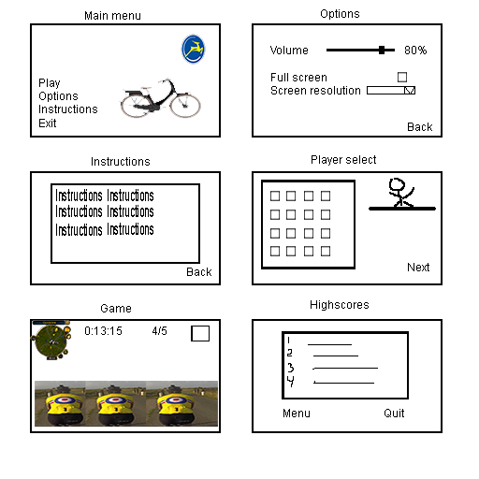

# Interactive Objects

|  |  |  |  |  |  |  |
| --- | --- | --- | --- | --- | --- | --- |
| **Object** |  | **Type** |  | **Use** |  | **How to Use** |
| Start |  | Button |  | Start the game |  | Mouse click |
| Options |  | Button |  | Open the options |  | Mouse click |
| Instructions |  | Button |  | Give instructions |  | Mouse click |
| Back |  | Button |  | Go back to previous screen |  | Mouse click |
| Quit |  | Button |  | Quit the game |  | Mouse click |
| Item blocks |  | Items |  | Give a random item from the item pool |  | Drive trough it |
| Boosters |  | Booster |  | Gives you a speed boost |  | Drive over them |
| Player selection |  | Player |  | Picks a player to play with (not bike) |  | Mouse click |

# Behaviors

|  |  |  |  |  |  |
| --- | --- | --- | --- | --- | --- |
| **Type** |  | **Description** |  | **How does it do it?** | **Expectable situations** |
| Button |  | When clicked something happens |  | When you click with your mouse something happens (what the name of the button says) | Plays the game, opens the option menu, opens the rules menu, exits the game, goes back to the previous screen, opens the pause menu |
| Scoreboard |  | Shows the player the time of the laps and their position |  | If you open the highscore list you can see how well you do overall, and also shows you at the end of each game |  |
| Player |  | Everything the player can do will be done here |  | It takes the input from the player, and uses it. |  |
| UI |  | Keeps track of everything in UI (pos/time) |  | It takes the race time and checks the players position according to the other players |  |
| Items |  | Can be picked up and used |  | If a player picks up an item it can be used to slow down other players |  |
| Booster |  | Gives a speed boost when driver over |  | Gives players a small speed boost for a few seconds |  |

# Object relationships

